Prompt
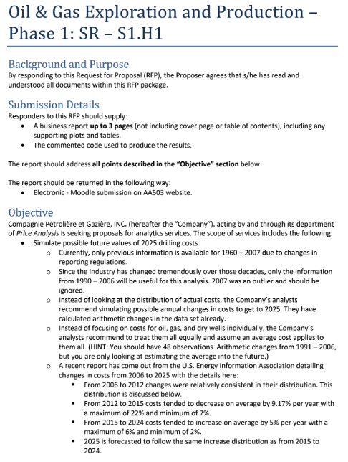
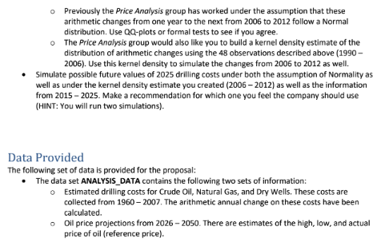

Breakdown
Breakdown here

Report

Report is subtab

Code and Plots
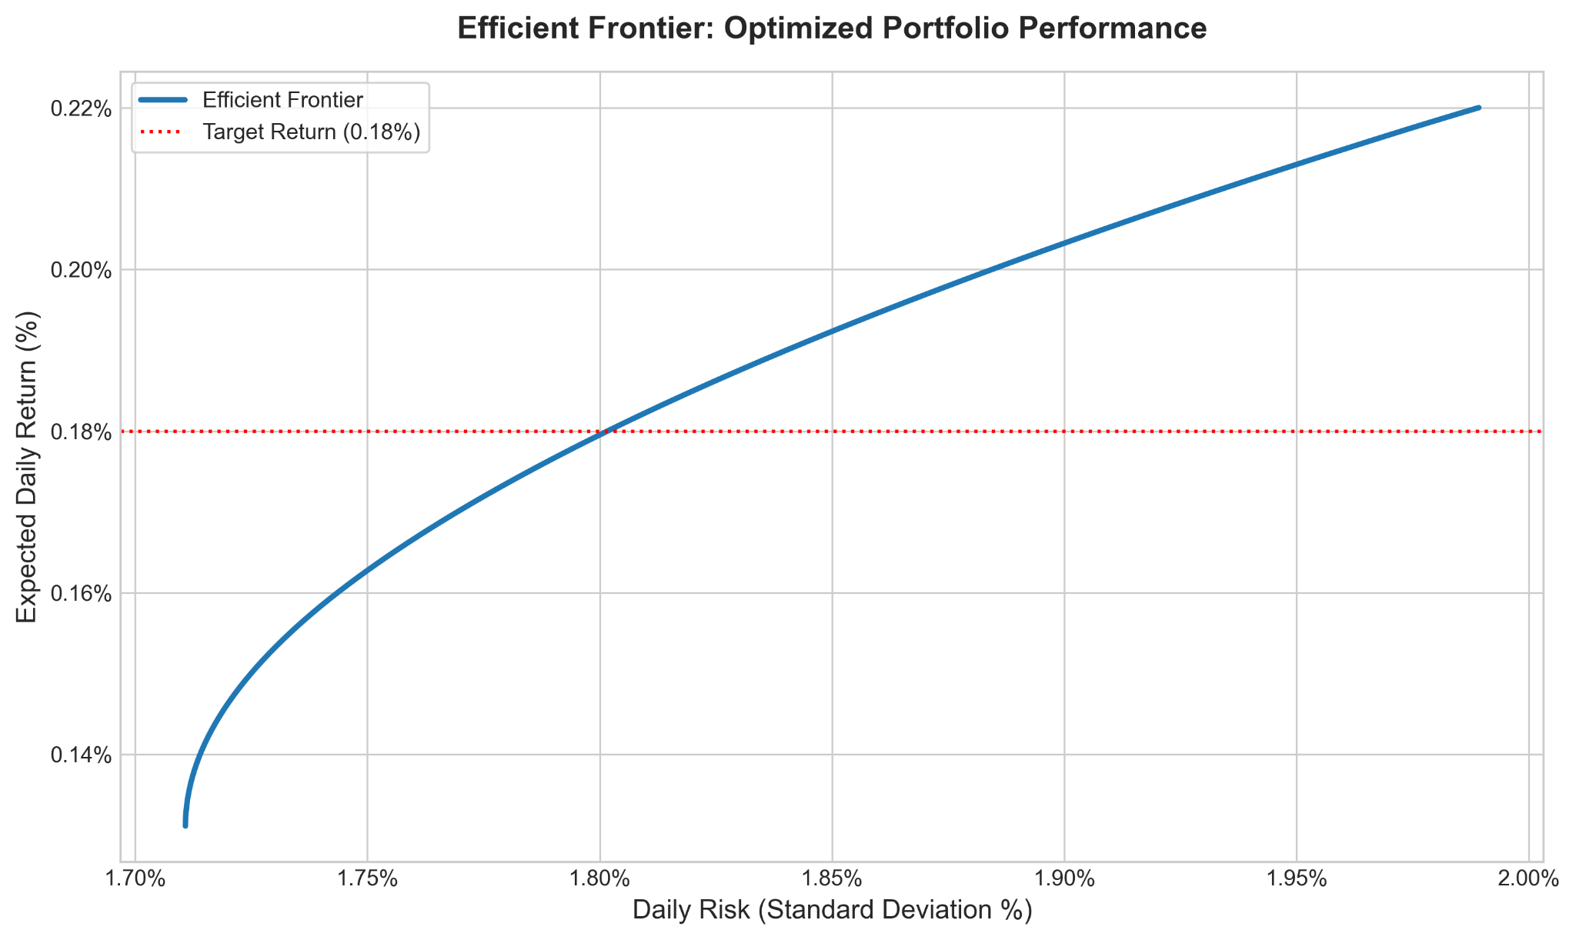

Table 1: Optimal stock portfolio allocation to minimize risk.
Stock | Percentage of Portfolio
Alphabet Incorporated (GOOG) | 43.02%
Alphabet Incorporated (AAPL) | 34.78%
Meta Platforms Incorporated (META) | 19.49%
Broadcom Incorporated (AVGO) | 0%
NVIDIA Corporation (NVDA) | 0%
Estimated Risk: 1.71% | Estimated Daily Return: 0.1312%

Table 2: Optimal stock portfolio with balanced risk and expected daily return.
Stock | Percentage of Portfolio
Alphabet Incorporated (GOOG) | 71.24%
Alphabet Incorporated (AAPL) | 15.80%
Meta Platforms Incorporated (META) | 10.38%
Broadcom Incorporated (AVGO) | 1.49%
NVIDIA Corporation (NVDA) | 1.10%
Estimated Risk: 1.80% | Estimated Daily Return: 0.1798%

Table 3: Optimal stock portfolio allocation to maximize daily returns.
Stock | Percentage of Portfolio
Alphabet Incorporated (GOOG) | 91.64%
Broadcom Incorporated (AVGO) | 5.09%
NVIDIA Corporation (NVDA) | 3.18%
Meta Platforms Incorporated (META) | 0.09%
Alphabet Incorporated (AAPL) | 0%
Estimated Risk: 1.99% | Estimated Daily Return: 0.22%

Report Here

Future Drilling Costs Simulation

Team 4
Lukman Awad, Irvin Carreon, Seamus Flaherty, April Groce, Grayson Nico

April 2, 2026

Table of Contents

Overview 1
Methodology 1
Data Used 1
Data Preparation 1
Analysis 1
Testing Normality 1
Simulations 2
Results & Recommendations 3
Results 3
Recommendations 3

Future Drilling Costs Simulation

Overview
Compagnie Pétrolière et Gazière, Inc. (hereafter referred to as “Company”) requested a simulation of possible future values for 2025 drilling costs by modeling annual changes in cost. The Price Analysis group had previously assumed that the arithmetic changes during the 2006-2012 period followed a normal distribution but asked our team to further investigate this assumption. To address this request, our team developed two separate simulations using different distributional assumptions for the 2006-2012 time period. Given our investigation, we recommend that the Company utilize our first simulation that follows the assumption of normality from 2006-2012.

Methodology
The following section describes the structure and preparation of the data for our simulation.

Data Used
Our team utilized a dataset containing estimated drilling costs for crude oil, natural gas, and dry wells from 1991-2007. The dataset included the arithmetic annual change in these costs from one year to the next for each well type. Following the provided recommendations, we excluded the 2007 drilling cost data from our analysis, as it was considered an outlier year.

Data Preparation
To prepare the data for simulation, we treated the costs for oil, gas, and dry wells equally and assumed that a single average cost could be applied across all well types. Prior to restructuring the dataset with this assumption, we calculated the average drilling cost across oil, gas, and dry wells in 2006 to obtain a single starting value for the simulation. With this starting point established, we restructured the dataset to include only the arithmetic changes, with each date and well type combination represented as a single row.

Analysis
This section presents our evaluation of the normality assumption and describes the two simulation scenarios used to model drilling costs.

Testing Normality
To address the Price Analysis group’s request to evaluate whether normality was a valid assumption for the 2006-2012 time period, we created a normal quantile plot and conducted a Shapiro-Wilk test on the arithmetic changes in cost from 1991-2006. The normal quantile plot is shown in Figure 1.
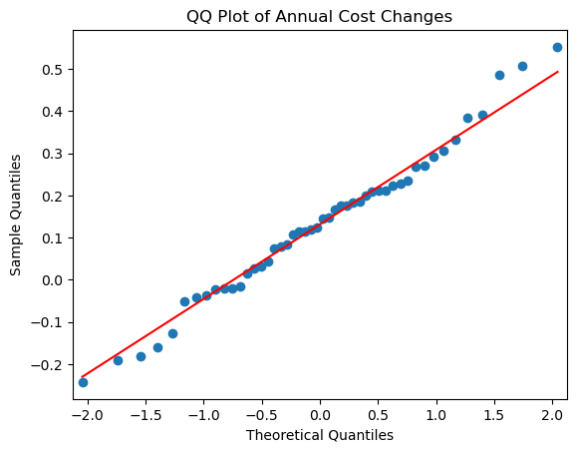
Figure 1: Normal Quantile Plot of Arithmetic Changes from 1991-2006

As shown in Figure 1, the data generally follows the 45-degree reference line, indicating that the distribution is approximately normal. This conclusion is further supported by the Shapiro-Wilk test, which produced a p-value of 0.80. Because this p-value is well above common significance levels, we fail to reject the null hypothesis of normality, suggesting that the distribution of annual cost changes from 1991-2006 is approximately normal. This supports the use of a normal distribution for the simulation of arithmetic changes from 2006-2012. Given this investigation, and the requests of the Price Analysis group, we ran two simulations that are detailed in the following section.

Simulations
In this section, we outline the two simulation scenarios used to model drilling costs for the 2006-2025 time period. The distributional assumptions applied to each time period in each simulation are summarized in Table 1.

Table 1: Outline of Simulations
 | Simulation 1 | Simulation 2
2006-2012 | Normal | Kernel Density Estimate
2012-2015 | Uniform with a minimum of -22% and a maximum of -7% | Uniform with a minimum of -22% and a maximum of -7%
2015-2024 | Uniform with a minimum of 2% and a maximum of 6% | Uniform with a minimum of 2% and a maximum of 6%
2025 | Uniform with a minimum of 2% and a maximum of 6% | Uniform with a minimum of 2% and a maximum of 6%

As shown in Table 1, the two simulations are identical except for the 2006–2012 time period. In Simulation 1, the annual cost changes during this period are modeled using a normal distribution, while Simulation 2 uses a kernel density estimation.

For the 2012-2025 period, the U.S. Energy Information Administration reported that changes in annual drilling costs varied over the period. Between 2012-2015, annual costs decreased by an average of 9.17%, with a maximum decrease of 22% and a minimum decrease of 7%. From 2015-2024, annual costs increased by an average of 5%, with a maximum increase of 6% and a minimum increase of 2%. The U.S. Energy Information Administration expects drilling costs in 2025 to follow the same distribution of increases observed during the 2015–2024 period. These reported distributions are incorporated into the corresponding time periods in both simulations.

Results & Recommendations
This section outlines the results of our analysis and gives recommendations for future decision-making.

Results
After running both simulations, one assuming a normal distribution for the 2006–2012 time period and the other using a kernel density estimate, we found that drilling costs are projected to increase to an average value of approximately $4.4K across simulations. The probability that costs fall below the initial estimate is approximately 7.85% for Simulation 1 and 9.39% for Simulation 2, indicating that cost reductions are unlikely.

Recommendations
Based on these results, our team recommends using Simulation 1 when simulating possible future values of 2025, as the results are similar to the Simulation 2 as seen in Figure 2.

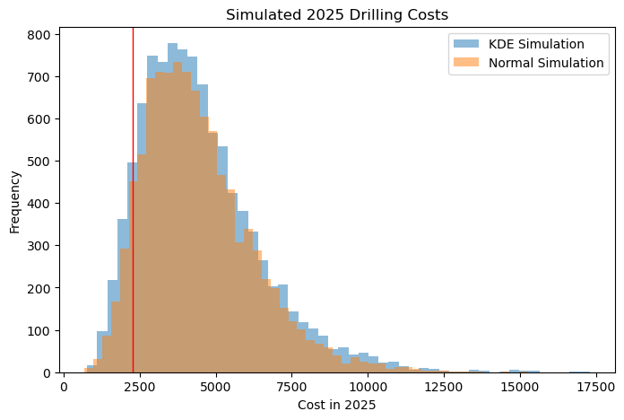
Figure 2: Simulated 2025 Drilling Costs

As shown in Figure 2, both simulations produce very similar results. Given this similarity, Simulation 1 is preferred because it models the 2006–2012 period using a normal distribution, resulting in a simpler model with a lower risk of overfitting.

Conclusion
Based on our evaluation of the normality assumption using historical data, we recommend that the Company utilize Simulation 1, which models the 2006–2012 period using a normal distribution. While this simulation provides a useful estimate of potential drilling costs in 2025, the results should be interpreted as projections rather than exact forecasts.

HW Report Checklist

Homework Report Checklist - Team 4

As instructed by Hiya and Dr. Egan Warren, the team member(s) responsible for checking each item should enter their initials in the field next to each question. All items should be addressed before submitting the assignment with the initialed checklist attached.

Sections & Structure

Overview
AG | Is the overview concise?
AG | Does it provide context about the business problem? <Content>
AG | Does it briefly address your team’s work, quantifiable results, and recommendations? <Action>
AG | Does it offer audience-centered reasons for recommendations? <Context>

Body Sections
AG | Does the report body include information on methods, analysis, quantifiable results, and  recommendations?
AG | Is content grouped into appropriate sections (methodology, analysis, results, recommendations)?

Conclusion
AG | Does the report have a conclusion?
AG | Does the conclusion sum up the report and emphasize relevant takeaways?

Structure
AG | Does each major section have a heading?
AG | Are sections, subsections, and paragraphs organized logically for easy navigation?

Visuals

Introduction, Discussion, and Captions
SJF | Is each visual introduced in the text before it appears?
SJF | Is each visual close to where it is introduced?
SJF | Does each visual include a title with the following information: type (table or figure), number, and a  descriptive caption?
SJF | Is each visual discussed and interpreted in the text?
SJF | Are figures and tables numbered separately?
SJF | Are table captions above the table? Are figure captions below the figure?

Visual Design
IC | Do figures/tables use audience-friendly labels rather than variable names?
IC | Are the visuals easy to interpret?
IC | Are the visuals appropriately sized?
IC | Do tables appear on one page (not split between 2 pages)?
IC | Are legends and axis labels included for figures?
IC | Are numbers in tables right aligned?
IC | Are the visuals designed well (ex: re-created in Word or Excel, not blurry or stretched,…)?

Document Design

Title Page Design
GN | Does it include a descriptive title?
GN | Does it state the team name, team members’ names, and the submission date?

Table of Contents Design
GN | Does it list all the major sections of the report with corresponding page numbers?
GN | Do the page numbers and sections in the Table of Contents match the report?

Document Design for Entire Report
GN | Is a standard typeface (Calibri, Arial, etc.) used?
GN | Is the size of the body text between 10-12 pt.?
GN | Are headings and subheadings used to organize information?
LA | Are distinctive text styles (bold, italic, etc.) used to distinguish between heading levels?
LA | Are text styles for headings used consistently (ex: all level-one headings are bold)?
LA | Are all paragraphs an appropriate length (fewer than 12 lines)?
LA | Is white space used to indicate paragraph breaks?
LA | Are bullet lists used for a series of items and numbered lists to show a hierarchy?

Writing Style and Mechanics

Spelling and Capitalization
LA | Are spelling errors located and corrected?
LA | Is spelling consistent throughout (no switching between acceptable spellings)?
LA | Is capitalization used appropriately (proper nouns, etc.)?
SJF | Is capitalization of words consistent throughout the report?

Grammar and Punctuation
GN | Are verb tenses used appropriately?
GN | Are marks of punctuation used appropriately?
GN | Is subject-verb agreement used in every sentence?
GN | Is the grammar checker updated and are underlined grammar issues addressed?

Writing Style
LA | Are all sentences in the report easy for your audience to understand quickly?
LA | Are most sentences written in active voice?
LA | Are idioms and vague words eliminated from the report?
LA | Are acronyms introduced before being used?
LA | Are well-written topic sentences included at the beginning of each paragraph?
LA | Are lists parallel?
LA | Is the appropriate point of view used when addressing your audience or describing team actions?

